**THE PEARL EXAMINATIONS 2024**

**TERM II QUALITY ASSURANCE**

**BABY CLASS: (3 – 4 YEARS)**

**LEARNING AREA 1: SOCIAL DEVELOPMENT**

**My name is: ………………………………..………………………….**

**My School is: ……………………………..……….…………………..**

**I am in: ………………………………..…………………………………………..**

1. **Tell the following.**

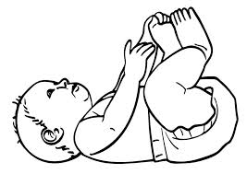

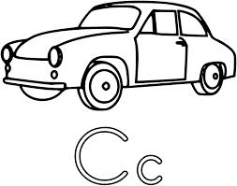

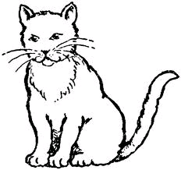

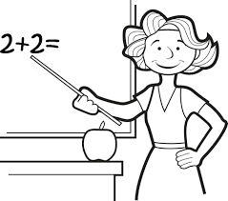

1. 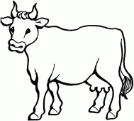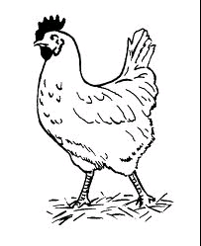**Match correctly.**

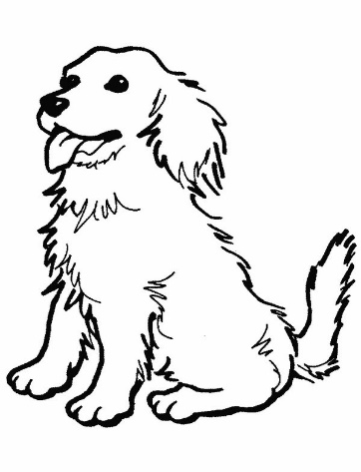

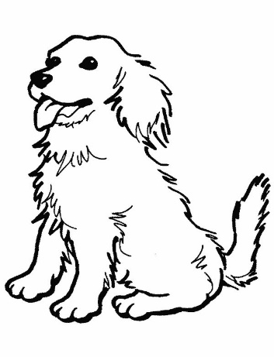



1. **Draw these people found at home.**

|  |  |
| --- | --- |
|  |  |
|  |  |
|  |  |
|  |  |

1. **Circle the same people wear.**

|  |  |  |
| --- | --- | --- |
|  |  |  |
|  |  |  |
|  |  |  |
|  |  |  |

**END**